Naveen Sellathurai
nsel0009@student.monash.edu
FIT5032 Assignment 1.1
Design Report

Declaration
I, Naveen Sellathurai, declare that this assignment, titled [Assignment Title], is my own original work and has not been copied from any other source except where explicitly acknowledged. I have not engaged in plagiarism, collusion, or any other form of academic misconduct in the preparation and submission of this assignment. All sources of information and data used in this assignment have been properly cited and referenced in accordance with the prescribed guidelines. I have not used unauthorized assistance in the preparation of this assignment and have not allowed any other student to copy my work. I am aware that any breach of academic integrity may result in disciplinary action as per the policies of Monash University, which may include failing this assignment or the course, and further academic penalties.

Signature: Naveen Sellathurai Date: 16/08/2026

Github Check
Enter your Github details here.
Github Username  Enter your username here | nsel0009
Repository Shared?  Have you started and shared your assignment repository with your tutor yet? | No  (Waiting For The Dedicated Tutor. I have added ABM Russel, However)

Self-Evaluation
Rate your performance for each criteria. Put a ✅(tick) in the box where you think your work belongs.

Criteria | Exceeds Expectations | Meets Expectations | Needs Improvement | Fail to meet expectations
Executive Summary |  | ✅
User Personas |  | ✅
Sitemap |  | ✅
Wireframes/Low-fidelity Prototype |  | ✅

Section 1: Executive Summary
The following project involves producing a web application for a Not For Profit (NFP) Organisation that works around promoting climate action and environmental sustainability in local and underrepresented communities. This project focuses on Environmental Education and Climate Literacy, helping customers through two primary methods.
One is by providing insightful information through a map that pinpoints areas where climate is important to analyse and evaluate. This would involve traversing the map and pressing on points of interest to receive text bubbles about them.
The other way is by booking spots in online Climate Literacy classes that help educate customers about climate resilience and environmental protection, and particularly about how innovative technology solutions can help benefit vulnerable groups and underrepresented communities.
Climate Literacy involves learning about the foundation of understanding the greenhouse effect and how humans affect climate change, providing insights into how people can assess their own surrounding environment. The greenhouse effect is where the Earth’s atmosphere uses its gas composition to trap heat that travels from the sun. Climate Literacy is important because our current artificial practices are causing more drastic changes in climate, with the Earth’s temperature having a gradual increase over the years. Being more informed about how we can use technological solutions for environmental needs means that there can be a focus in sustainable solutions that cause minimal damage without sacrificing economical needs. Understanding the balance between economic and environmental challenges will therefore be a key focus in Climate Literacy education.
The web application focuses on people who want to be more educated about Climate literacy for their own personal reasons, businesses that help underrepresented communities and climate issues, and these underrepresented communities themselves. Ultimately, the goal that the NPM organisation want to achieve with the web application is to provide a service for their customers that can help educate them more about Climate resilience and climate issues in communities that may need help around this issue and providing insights about technological solutions that can be used to help out in these situations.

Section 2: Sitemap

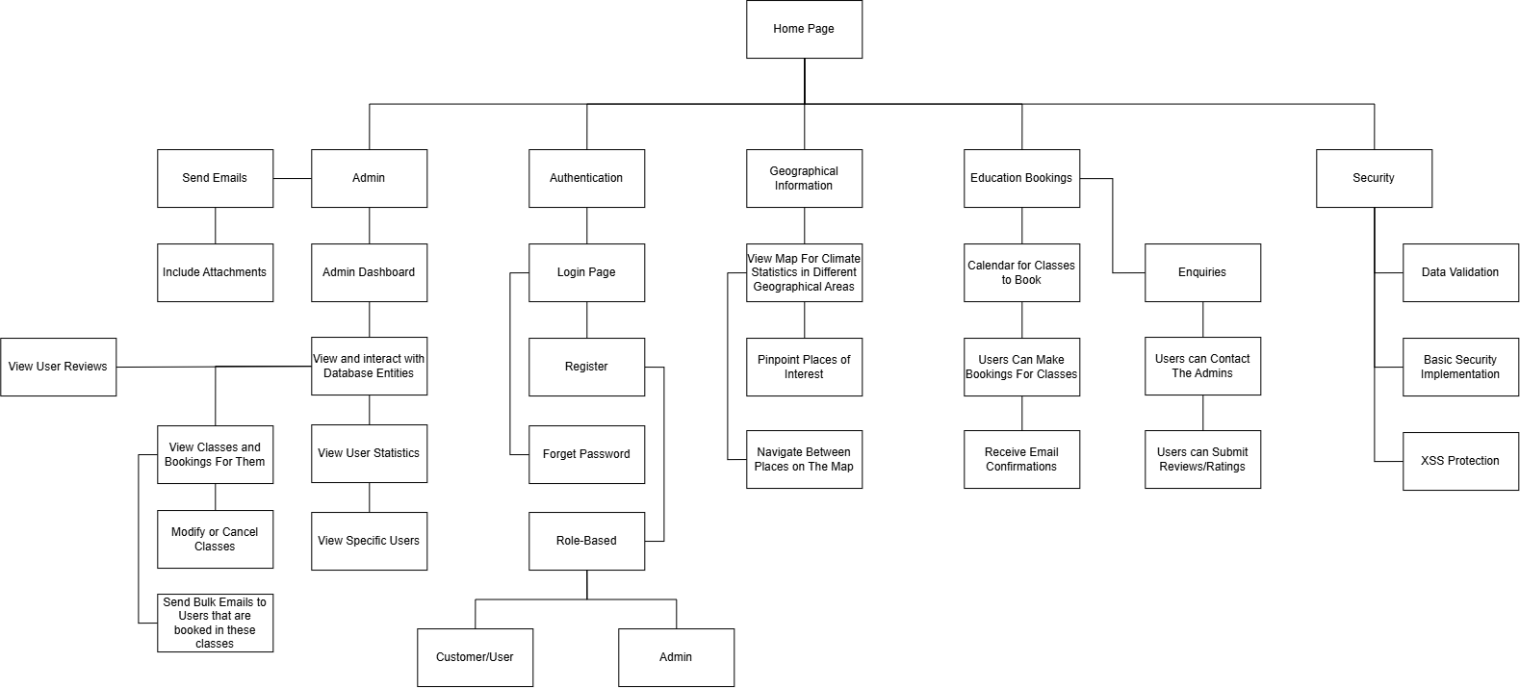

Section 3: User Personas
Persona 1: A university student who wants to learn more about Climate Resilience
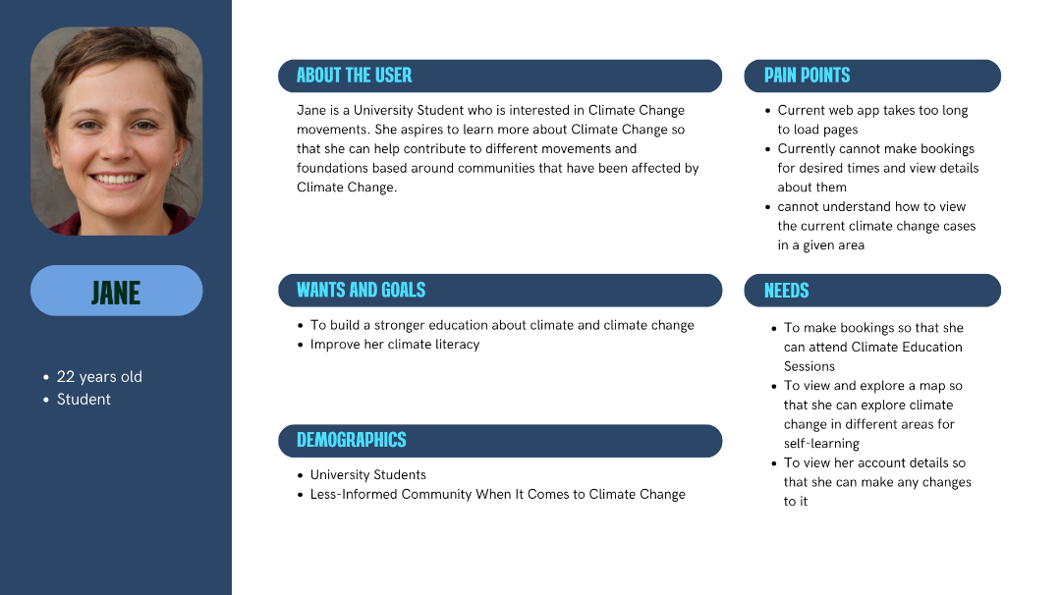
Persona 2: A business owner who wants to help different communities in different climate areas
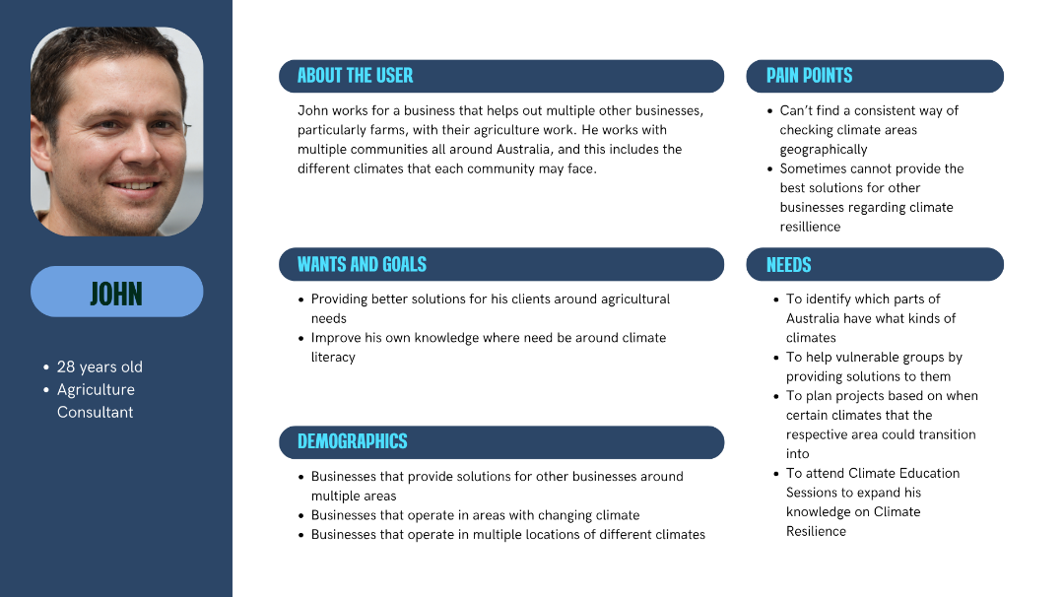
Persona 3: An administrator for the NFP Organisation
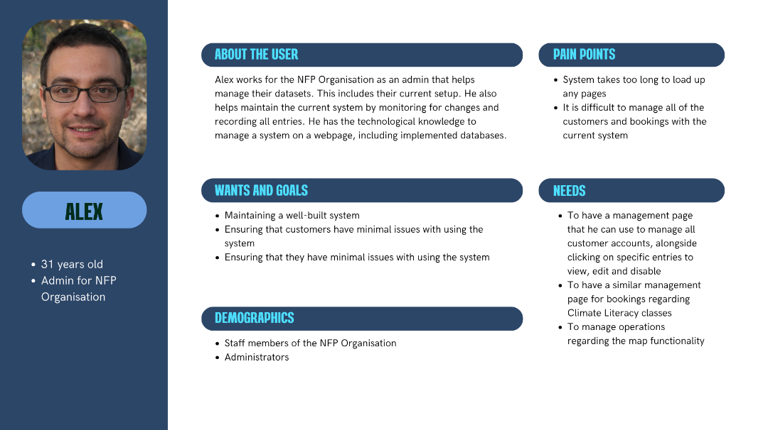

Section 4: Wireframes/Low-fidelity prototype
The first set of low fidelity wireframe diagrams involve the landing page when no one is logged in, the profile pages when logged in as either a customer or an admin, and the settings page that you can access by pressing the profile icon at the top right (The circle image).

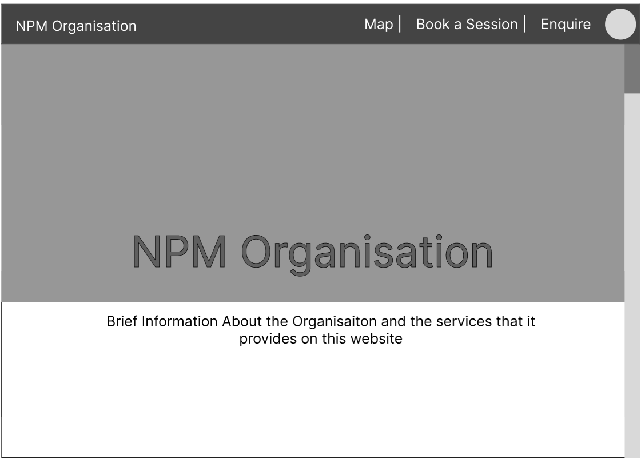

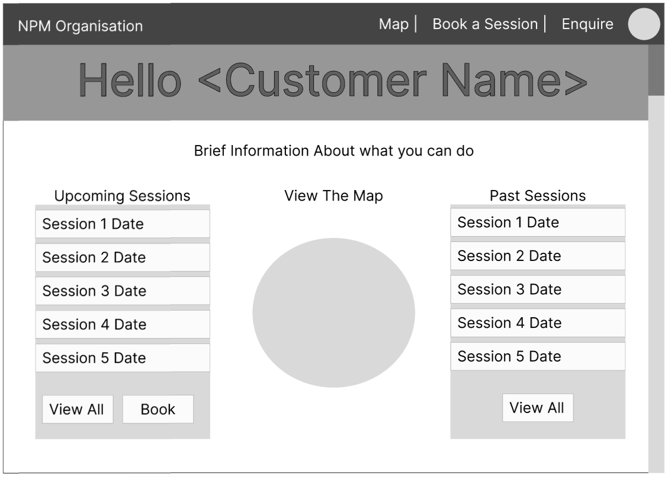 | 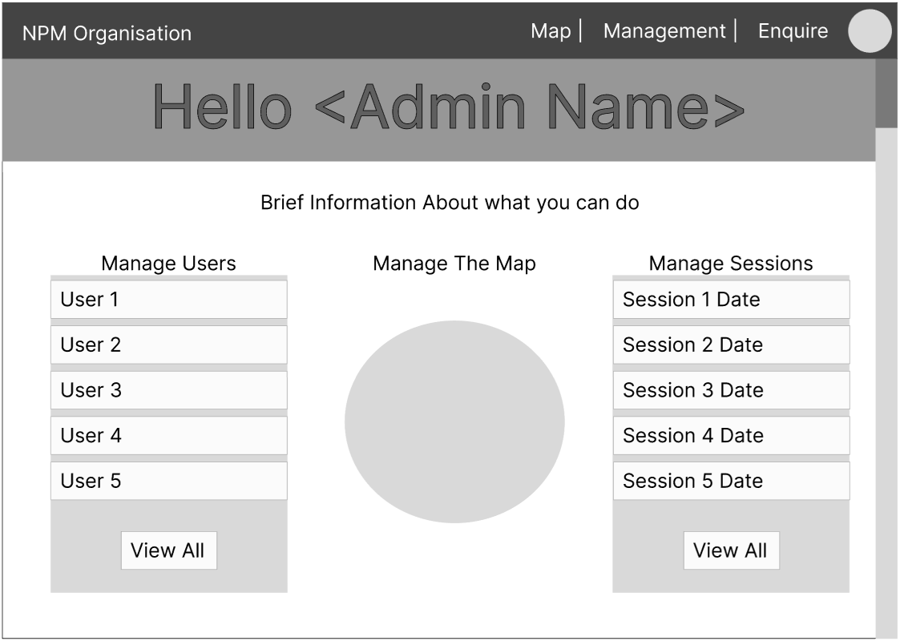
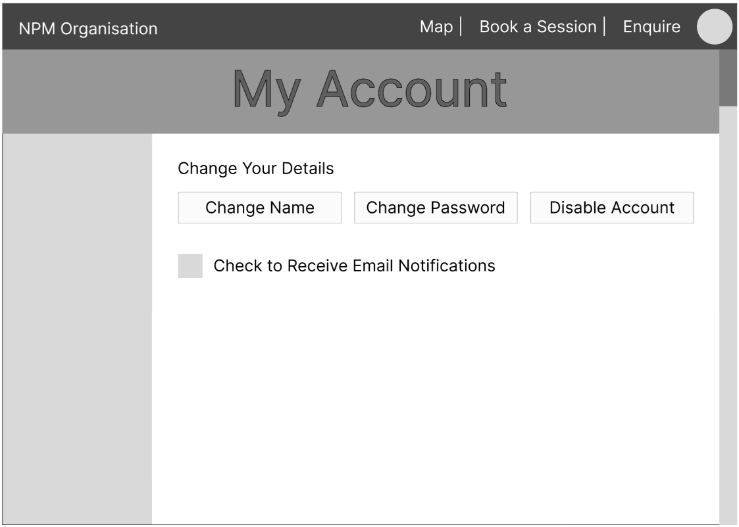

The next set of wireframe diagrams each are grouped up accordingly with one of the business requirements of this project. This totals to three extra groups, as three business requirements (C.1, D.3 and F.1) are the main focal points for the following. The criteria are in Italics for differentiation.

BR (C.1): Authentication
The new Web Application must have a basic authentication mechanism (login/register functionality and user accounts) to provide confidentiality.

The user can choose to log into a pre-existing account or register a new account. The registered account will be registered as a customer, as admin accounts are added in via the backend so that only the staff members can add admin accounts. The registration page can be scrolled down, as shown with the two views. A user can also reset a password.

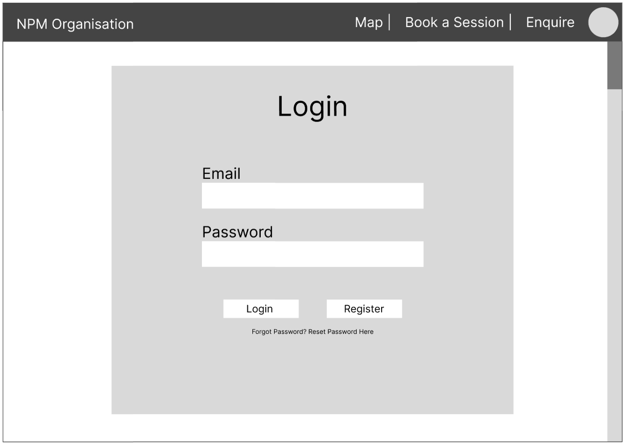

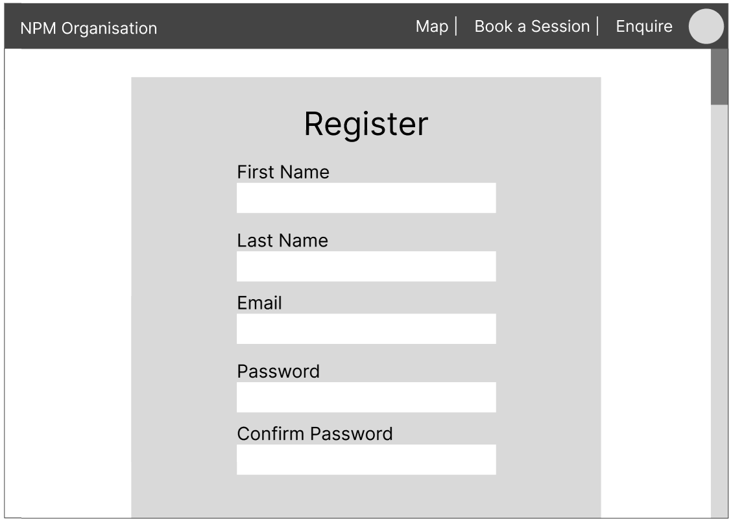 | 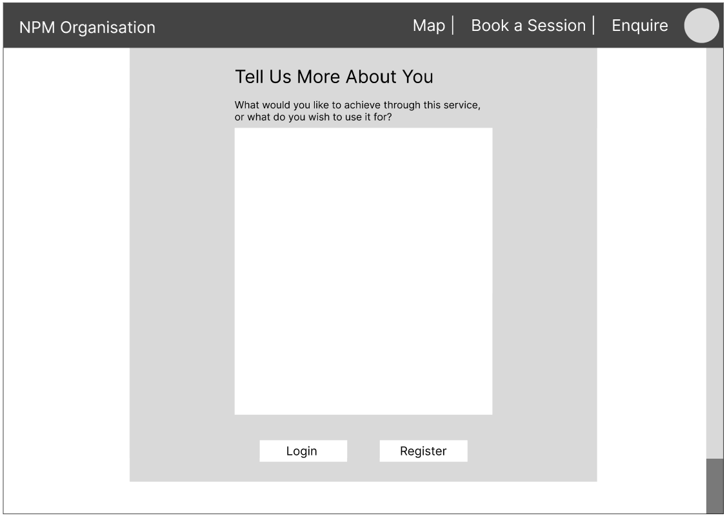
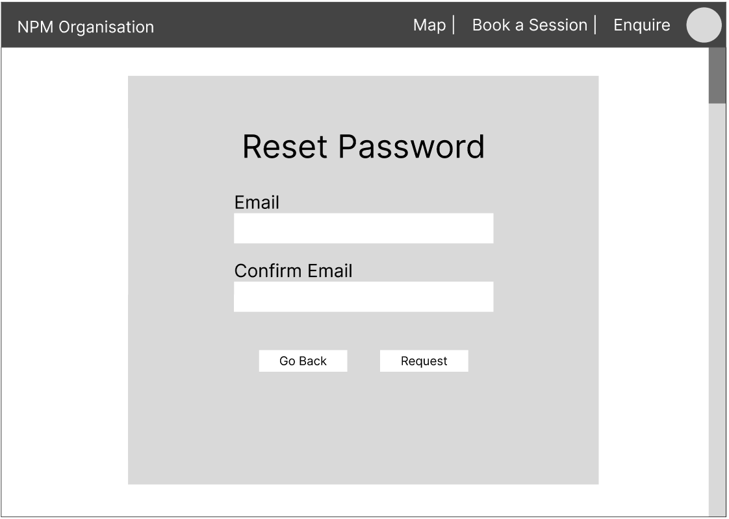

BR (D.3): Interactive Table Data
The new Web Application must display interactive table data with a minimum of two tables. The table needs to support: sort, search and limit to 10 rows per page. User must be able to search by individual column.

Admin accounts can view all users accounts and all sessions in a table, including viewing and editing them. There is a search functionality and the ability to switch between pages for when there are more than 10 entries.

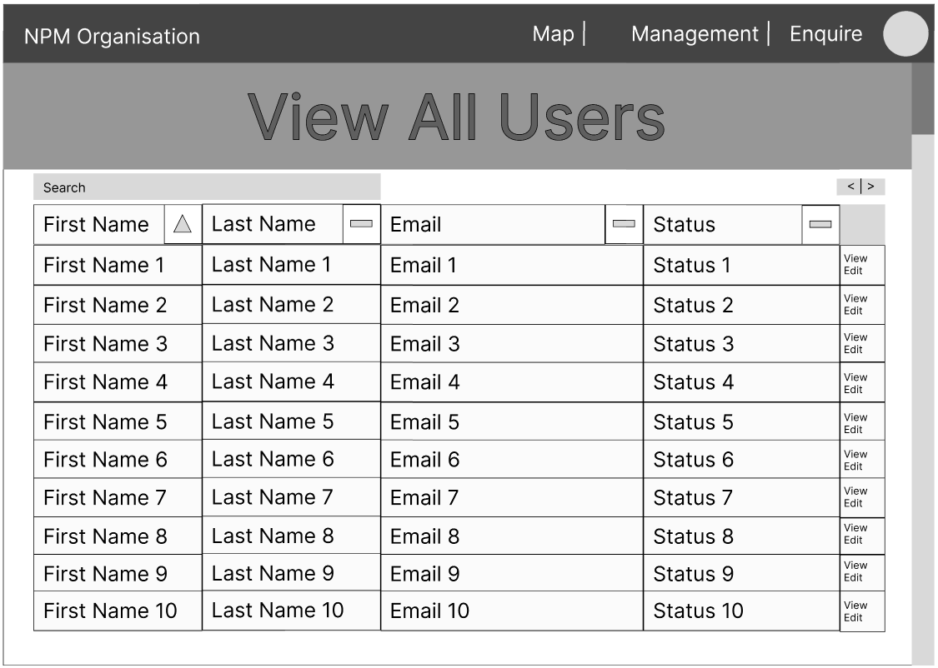 | 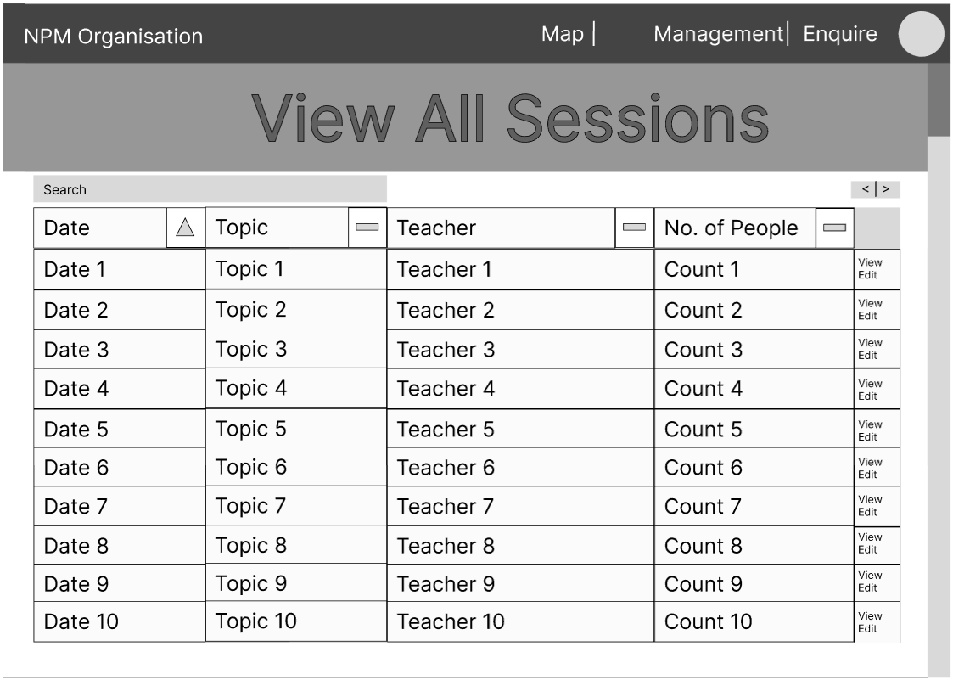

BR (F.1): Innovation
The new Web Application must implement four extended innovative features aimed at improving User Experience (UX). A research report with details on which features have been implemented and recommendations for future upgrades must be prepared and submitted. Note that implemented innovations may represent enhancements to existing features. Examples of extended innovative features:
- Appointment Booking (using Calendar): The new Web Application must implement booking constraints such as booking conflict management using Calendar. Hint: Displaying features on a Calendar such as event constraint can be done using FullCalendar.io API

In this case, the chosen one of the four selected extended innovative features that will be represented in the Wireframe is the Appointment Booking. Customers can book Climate Literacy Class sessions by accessing the calendar. The Calendar shows all available timeslots on a Calendar that shows all dates, grouped by months like a real-world calendar.

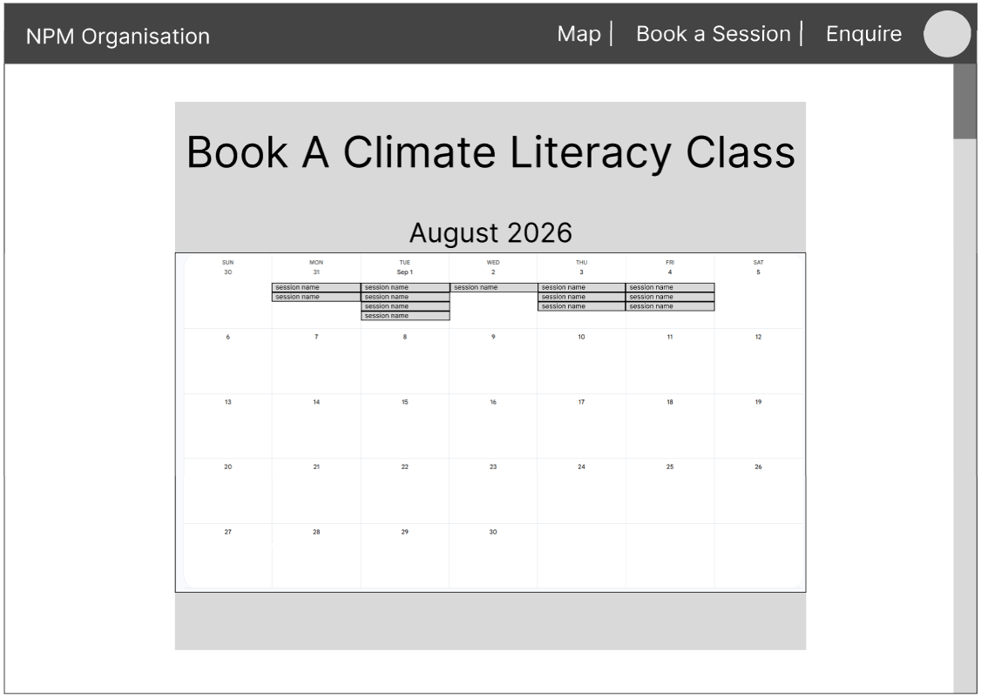 | 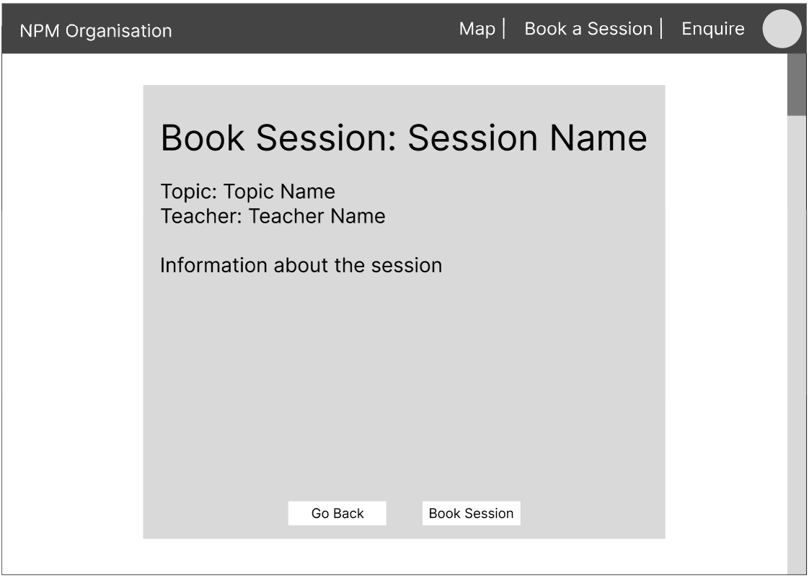

Declaration: Additional Help
Name | Description
Draw.io | Used to create the Site Map for the webpage. A blank canvas was used and the diagram was made from scratch.
Canva | User Personas were made using the template in the link below. The template was modified to use a different colour scheme and different subheadings based on the criteria.  https://www.canva.com/templates/EAEwgjKMvro-user-personas-presentation/
ThisPersonDoesNotExist | Used for the images for the User Personas  https://thispersondoesnotexist.com/
Figma | Used for the low fidelity wireframe diagrams. A blank canvas was used and the diagram was made from scratch.

References
Climate Literacy Australia. (2025). What is climate literacy? https://climateliteracy.com.au/climate_literacy_explained/

National Oceanic and Atmospheric Administration. (n.d.). What is climate science literacy? Climate.gov. https://www.climate.gov/teaching/what-is-climate-science-literacy

